CSC-272: Big Data Spring 2020

PROBLEM SET #3 – Due Wednesday, February 26 @ 9:30

Name: Boone Tison

All answers are to be word-processed, but scratch work can be hand-written.

Consider the following dataset:

1. Use the 1R algorithm discussed in class to evaluate the predictive ability of each of the input attributes. (Diagnosis is the output/class attribute.) See the class notes with the summary of rules for the credit card promotion dataset if you have any formatting questions. Do this by hand. You may use Weka for confirmation, but the point is for you to work through the algorithm yourself.

Attribute | Rules | Rule Accuracy | Overall Accuracy (%)
Sore Throat | Yes -> Allergy*  No -> Cold* | (2 out of 5)  (2 out of 5) | 40%
Fever | Yes -> Cold  No -> Allergy | (4 out of 5)  (3 out of 5) | 70%
Swollen Glands | Yes -> Strep throat  No -> Cold | (3 out of 3)  (4 out of 7) | 70%
Congestion | Yes -> Cold  No -> Strep throat | (4 out of 8)  (2 out of 2) | 60%
Headache | Yes -> Allergy*  No -> Cold* | (2 out of 5)  (2 out of 5) | 40%

Which attribute would you use to get the best predictive results? Why?
The best predictive attribute for 1R is Swollen Glands. Swollen Glands has 70% accuracy, tied with Fever. However, swollen gland’s goodness is 70%, in comparison to fever’s 35%.

2. Note that Patient ID# was not included in the results table. Show the rules that 1R would generate for this attribute, assuming no minimum bucket size.
1 -> Strep throat, 2 -> allergy, 3 -> cold, etc.

What is the overall accuracy of this Patient ID# rule set?
100%

Why not use this rule set as the best 1R output for this dataset?
Patient ID is a unique identifier. It produces one rule per instance. This is a classic example
of overfitting.

Next, consider this revised medical diagnosis dataset:
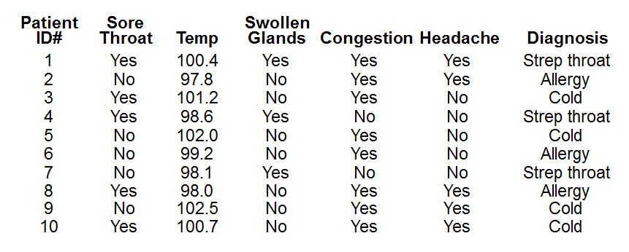
3. Consider the numerical data for the Temp attribute (replacing Fever in the original dataset). What rules does 1R generate for the best binary split on this data? Show your work.

Temp | 97.8 | 98.0 | 98.1 | 98.6 | 99.2 | 100.4 | 100.7 | 101.2 | 102.0 | 102.5
Diag | Allerg | Allerg | ST | ST | Allerg | ST | Cold | Cold | Cold | Cold

Attribute | Rules | Rule Accuracy | Overall Accuracy (%)
Temp | <= 100.4 -> Allergy*  >= 1007. -> Cold | (3 out of 6)  (4 out of 4) | 70&

4. Repeat the application of 1R to the Temp data but with a minimum bucket size of 2. (HINT: If you build the buckets by working from the right, you get a more satisfactory result.) Show your work.
Temp | 97.8 | 98.0 | 98.1 | 98.6 | 99.2 | 100.4 | 100.7 | 101.2 | 102.0 | 102.5
Diag | Allerg | Allerg | ST | ST | Allerg | ST | Cold | Cold | Cold | Cold

Attribute | Rules | Rule Accuracy | Overall Accuracy (%)
Temp | >= 100.7 -> Cold  <= 100.4 and >= 98.1 -> Strep throat  <= 98.1 -> Allergy | (4 out of 4)  (3 out of 4)  (2 out of 2) | 90%

5. Refer again to the first, fully nominal dataset. Ignore the Patient ID# attribute. Complete the probability table on the next page. (Portions have been filled out for you already.) Be sure to use the Laplace estimator to fix any zero probabilities, as the partially-completed table shows.
 | Sore Throat |  |  | Fever |  |  | Swollen Glands |  |  | Congestion |  |  | Headache |  |  | Diagnosis
 | Strep | Allergy | Cold | Strep | Allergy | Cold | Strep | Allergy | Cold | Strep | Allergy | Cold | Strep | Allergy | Cold | Strep | Allergy | Cold
YES | 2 | 1 | 2 | 1 | 0 | 4 | 3 | 0 | 0 | 1 | 3 | 4 | 1 | 2 | 2 | 3 | 3 | 4
NO | 1 | 2 | 2 | 2 | 3 | 0 | 0 | 3 | 4 | 2 | 0 | 0 | 2 | 1 | 2
YES | 2/3 | 1/3 | 2/4 | 1/3 | 0/3 | 4/4 | 3/3 | 0/3 | 0/4 | 1/3 | 3/3 | 4/4 | 1/3 | 2/3 | 2/4 | 3/10 | 3/10 | 4/10
NO | 1/3 | 2/3 | 2/4 | 2/3 | 3/3 | 0/4 | 0/3 | 3/3 | 4/4 | 2/3 | 0/3 | 0/4 | 2/3 | 1/3 | 2/4
YES* |  |  |  |  | 1/5 | 5/6 | 4/5 | 1/5 | 1/6 |  | 4/5 | 5/6
NO* |  |  |  |  | 4/5 | 1/6 | 1/5 | 4/5 | 5/6 |  | 1/5 | 1/6

* Adjusted with the Laplace estimator, if necessary

6. Use this data to compute the Naïve Bayes probabilities for the following new instance. Show all work. Be sure to normalize the answers as shown in lecture. Your answers below should be given in percentages, and they should add up to 100%.

Sore Throat | Fever | Swollen Glands | Congestion | Headache | Diagnosis
NO | NO | NO | NO | YES | ????

Probability of Strep Throat: 1/3 * 2/3 * 1/5 * 2/3 * 1/3 * 3/10 = .0029

Probability of Allergy: 2/3 * 4/5 * 4/5 * 1/5 * 2/3 * 3/10 = .0170

Probability of Cold: 2/4 * 1/6 * 5/6 * 1/6 * 2/4 * 4/10 = .0023

ST: .0029 / (.0029 + .0170 + .0023) = .1306 = 13.06%
All: .0170 / (.0029 + .0170 + .0023) = .7657 = 76.57%
Cold: .0023 / (.0029 + .0170 + .0023) = .1036 = 10.36%

7. What does 1R predict for the same new instance?
1R predicts Cold, based off of the rule swollen glands = no -> cold. The accuracy is 70%.

8. Based on these experiments, which classification algorithm – 1R or Naïve Bayes – would you trust more on this dataset, and why?
I would trust Naïve Bayes more for this dataset. Naïve Bayes predicts allergy with 76.57% accuracy versus 1R predicting cold with 70% accuracy. Naïve Bayes is also better because it incorporates more of the attributes.

